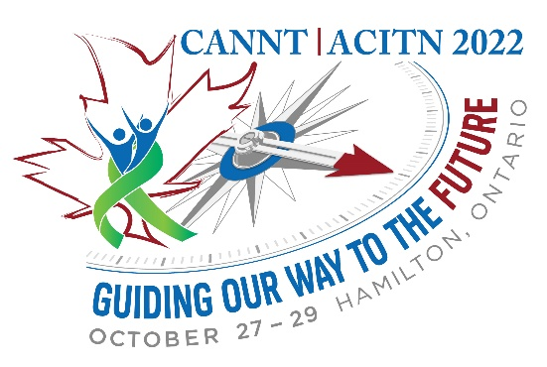CALL FOR ABSTRACTS
CANNT-ACITN invites you to join us in Hamilton October 27-29, 2022!
Abstracts are currently being accepted for ORAL and POSTER presentations for CANNT-ACITN 2022 – “Guiding our way to the future”. Abstract submissions should incorporate the theme—sharing our knowledge and experience—appropriate for the novice through to the advanced practice professional. Topics of interest may include: clinical research, innovative projects and solutions, ethics, case presentations and clinical reviews. All abstract submissions must be evidence-based.
Consistent with our theme, all poster and oral presenters will be encouraged to consider how their presentation can help guide us into the future.
ABSTRACT SUBMISSION GUIDELINES:
Deadline: April 30, 2022

All abstracts must be submitted online (www.cannt-acitn.ca) through the online submission form.
Submissions must include the following:
1) Abstract Title
- Must accurately reflect the content of the presentation
- Must be formatted in sentence case (capitalize first word and remaining words begin in lower case)
2) Authors and Affiliations
- Must be included under the title and formatted as follows:
Anne L. Smithª, RN, CNeph(C), Robert G. Jones^{a,b}, RN
ªDepartment of Nephrology, University of Toronto, Toronto, ON; ^{b}Department of Nephrology, University of Alberta Hospital, Edmonton, AB.
Underline the name and initials of the presenter(s).
3) Abstract Text
- Should be no longer than 250 words including headings (do not include pictures, tables or references)
- Should be as informative as possible
- Define all abbreviations the first time they appear in the abstract
- Use only the generic names of drugs
- Do not identify companies and/or products in the body or title of the abstract

If research-based, must include below headings:
- Purpose of study
- Methods
- Results
- Conclusions
- Implications for nephrology care
If practice/education/narrative-based, must include below headings:
- Purpose of the project
- Description
- Evaluation/outcome
- Implications for nephrology practice/education
LEADING EDGE TOPICS INCLUDE:
- Transplant
- Mental Health and CKD
- Cardiovascular Disease and CKD
- Future Directions of CKD and Treatment
- Pregnancy with Renal Disease
- Pediatrics
- Ethics and Elderly Care
- Medical Assistance in Dying
- Technical Advances in Dialysis Equipment
- Home Therapies
IMPORTANT NOTES:
Only COMPLETE submissions received by April 30, 2022 will be considered.
- All correspondence will be with the presenting author only
- Acceptance of abstract does not waive attendance fees (registration)
- Notification regarding selection decisions will be provided by July 25, 2022
- Should the abstract be selected for presentation, the author(s) authorize(s) the publication of the abstract submitted for publication in the CANNT-ACITN Journal
- The presentation shall not make comparison to companies or products for any purposes of product marketing, nor will topics or materials used discredit companies or products
- The abstract, and associated authors, should make full disclosure of corporate employment and/or funding sources
- Abstracts not in the required format will be returned to the author for revision
- The language of abstract submission will be the language of presentation, if selected
SUBMIT ABSTRACTS TO:
Online: www.cannt-acitn.ca
QUESTIONS:
Email: cannt@cannt.ca

